**MID TERM ONE ASSESSMENTS 2024**

**LEARNING AREA: LITERACY TWO**

**CLASS : PRIMARY ONE**

**PUPIL’S NAME :**

Each correct answer carries two (2) marks

**SECTION A**

**1.** Circle the words with sound “a”

Axe , box , arrow , shelter

wind , apple , food , cat

cup , jug , rat , clothes

**2.** Write “es” on the given words.

tomato tomatoes

mango _________________

flamingo _________________

potato _________________

**3.** Fill in the missing letters

head l ___ g ha ___ d (n, e)

**4a)** Underline the odd man out.

pen juice book pencil

Monday Tuesday week Friday Saturday

**b)** Write these words correctly.

lirg girl tca ___________

ybo _________ tpo ___________

**5a)** Write the name of your school.

________________________________________________________

**b)** Write these sentences correctly.

1. He takes breakfast

2. He goes to school

3. John wakes up early in the morning

4. He washes his face

1. __________________________________________________

2. __________________________________________________

3. __________________________________________________

4. __________________________________________________

**6.** Read and draw.

|  |  |  |  |  |
| --- | --- | --- | --- | --- |
|  |  |  |  |  |
| cat | book | pencil | jug | bench |

**7.** Write as one word.

chalk + board = chaklkboard

pine + apple = ___________________

sky + view = ___________________

bed + bug = ___________________

pig + let = ___________________

pea + cock = ___________________

**8.** Match correctly

y S

w R

x Z

z Y

r W

s X

**9a)** How many days make a week? (Seven, Eight)

________________________________________________________

**b)** Ring four days of the week.

Friday tree Sunday Monday

week Saturday

**SECTION B**

**10.** Name these pictures.

|  |  |
| --- | --- |
|  |  |
|  |  |

(bench, umbrella)

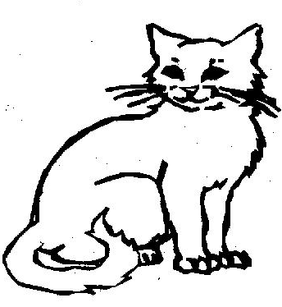**11.** colour this picture.

12. Copy and write the same.



________________________________________________________________________________________________________________________________________________________________________________________________________________________________________________________________________________________________________________________



________________________________________________________________________________________________________________________________________________________________________________________________________________________________________________________________________________________________________________________



_______________________________________________________________________________________________________________________________________________________________________________________________________________________________________________________________________________________________________________________